The Parlor
Course: GAME 360 - Development with Game Engines
Semester: Fall 2025
Student Name: C. “Allie” Metzger
Student ID: 01219518
Submission Date: 11/9/2025

1. GAME OVERVIEW (1 page)

Game Title
The Parlor

Genre
2D Platformer / 2D Shooter
Examples: "2D Platformer", "Top-down Puzzle", "Side-scrolling Action", "Tower Defense Strategy"

Target Audience
This game is meant to be a light-hearted and fun experience, so it is accessible to anyone willing to play. Although there will be shooting and platforming eves, none of them are very difficult, so it is also not a hard game to complete.

Estimated Playtime
5-10 minutes

Elevator Pitch
Have you ever walked into an ice cream parlor and thought to yourself, “what if I could platform and shoot ice cream cones”? If so, that’s oddly specific, but also, now you can! You play as a nameless employee who’s just starting out at the local treat destination, The Parlor. Try to survive your first day on the job…if you can…

Core Gameplay Loop
- Player goes through narrative section
- Player goes through level section (shooting or platforming)
  - Player defeats enemies to reach score
  - Player navigates obstacles to reach goal point
- Player kills boss after all levels are done
- Player wins game

Unique Selling Points
• Combination of shooting and platforming levels
• Ice Cream/Dessert themed narrative and environment
• Twist villain

2. GAMEPLAY DESIGN (1 page)
Content Guidance: This section details the actual mechanics of how your game is played. Be concrete—describe exact controls, specific mechanics, and clear win/lose conditions. Use examples from your Task 3 project where applicable.

Core Mechanics
Primary Mechanic 1: Shooting
• Description: Player can press F key to fire
• Purpose: Player can use mechanic to get rid of hostile enemies in order to progress with the level
Primary Mechanic 2: Platforming
• Description: Players can utilize jump, double jump, dash, and regular movement mechanics
• Purpose: Player can use mechanic to navigate levels that require more involved movement and traversal mechanics
Primary Mechanic 3: Narrative Interaction
• Description: Players read and interact with dialogue when it appears
• Purpose: Player gets a sense of the narrative/environment of the game world they are exploring
Player Controls
• Movement: WASD / Arrow Keys - Move character in 4 directions
• Jump: Spacebar - Vertical movement
• Primary Action: Fire - F
• Secondary Action: Left Shift – Dash
• Tertiary Action: Double Jump – Spacebar twice

Win Condition
Player wins by completing all platforming and shooting levels, as well as beating the final boss.

Lose Condition

Player health/lives reach 0

Timer reaches 0 on applicable levels

Game overs result in having to restart the current level

Progression & Difficulty
• Early Game: Player experiences basic narrative setup to the game, very easy shooting and platforming levels
• Mid Game: Levels steadily increase in difficulty/complexity
• Late Game: The game gets more difficult as you have to now beat the final boss

3. TECHNICAL PLAN (1 page)
Content Guidance: This is where you show how your Task 3 code will expand into your final game. Reference your existing Singleton, Observer, and State Machine implementations and explain how they'll grow. Be realistic about what's achievable in 6 weeks.

Pattern Integration & Expansion
Singleton Pattern Usage:
GameManager:
• Current (Task 3): Controls basic setup conditions for levels
AudioManager:
• Current (Task 3): Plays background music and basic sound effects
UIManager:
• Current (Task 3): Controls UI changes when certain events are updated

Observer Pattern Events:
Current Events (Task 3):
OnPlayerStateChanged
OnDoubleJump
OnScoreChanged
OnGameOver
OnLevelComplete
OnCoinCollected

State Machine Implementation:
Player State Machine:
• Current States (Task 3): Idle, Moving, Jumping,
• Needed State(s) (Final Expansion): Dashing

Features to Add (Weeks 11-16)
Map each feature to a week and specify which pattern(s) it uses:
Week 11: Dash Mechanic
□ Create dashing ability for player
Week 12: Boss Battle
□ Create basic boss fight
Week 13: Audio & Visual Systems
□ Use completed elements to create new levels to extend playtime
Week 14: Art
□ Analyze if game needs more art – if so, make more
Week 15: Polish/Testing
□ Test game for any leftover bugs or potential optimizations
Week 16: Presentation Preparation
□ Create demonstration/presenting materials

4. SCOPE & TIMELINE (1 page)
Content Guidance: This is YOUR reality check. Be brutally honest about what's achievable. It's better to have a polished, complete small game than an incomplete ambitious one. Explicitly state what you WON'T do.

Core Features (Must Have)
These are essential features that MUST be completed for a functional game.
□ Feature 1: Player movement and basic controls
□ Feature 2: Win/lose conditions
□ Feature 3: UI (health, score)
□ Feature 4: Audio system (music + SFX)
□ Feature 5: Dashing
□ Feature 6: Double Jump
□ Feature 7: Basic Boss fight
- Larger enemy with health system

Stretch Goals (If Time Permits)
These enhance the game but aren't critical for completion.
□ Goal 1: Health power-up
□ Goal 2: Bullet power ups
- Change speed
- Add another bullet
□ Goal 3: Adding music – not just sound effects

Will NOT Include
Explicitly state what you're cutting to maintain realistic scope.
❌ Cinematic cutscenes
❌ Inventory

5. ARTISTIC STYLE AND DESIGN CHOICES (1 page)
Content Guidance: Show inspiration and concrete plans for your game's look and feel. Include visual references and be specific about asset sources. This section demonstrates your artistic vision and resource planning.

Visual Style & Inspiration
Art Direction:
[Brief description of visual style. Example: "Clean, minimalist 2D art style with high contrast colors. Geometric shapes for environment elements, simple character sprites with readable silhouettes inspired by games like Thomas Was Alone and Celeste."]
Reference specific games, art movements, or visual styles. Include mood board images if possible.
Inspiration Examples:
• Game 1: Pony Island - [What you're taking inspiration from - e.g., "color palette and minimalist UI"]
• Game 2: Five Nights at Freddy’s: Pizzeria Simulator - [What inspires you - e.g., "particle effects and juice"]
• Art Style: [Reference] - [Why - e.g., "Flat design for quick asset creation"]
Color Palette:
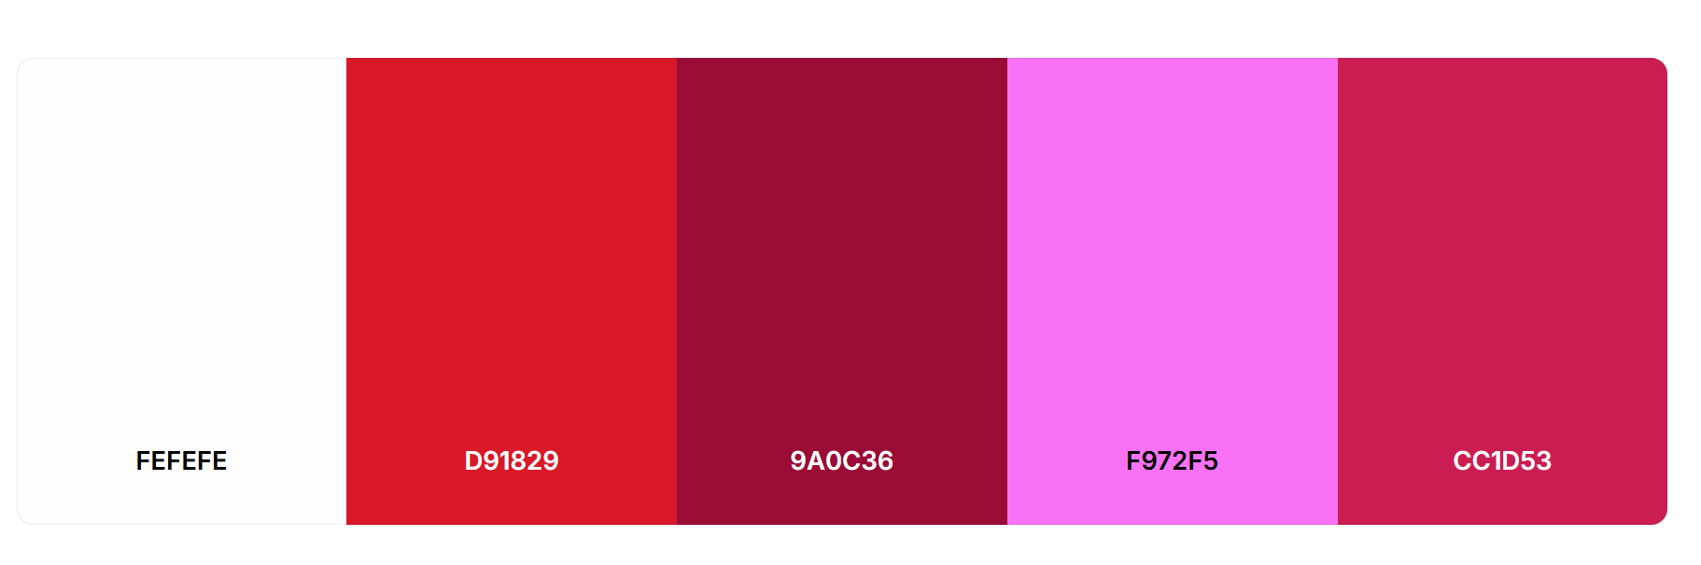
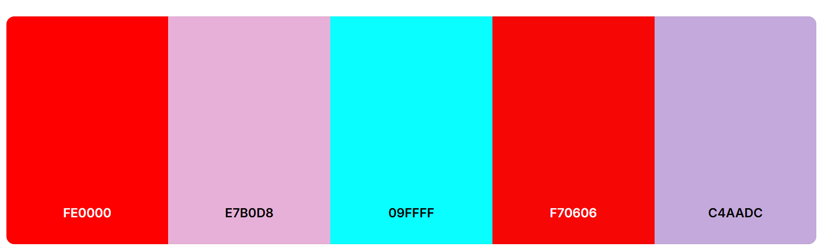
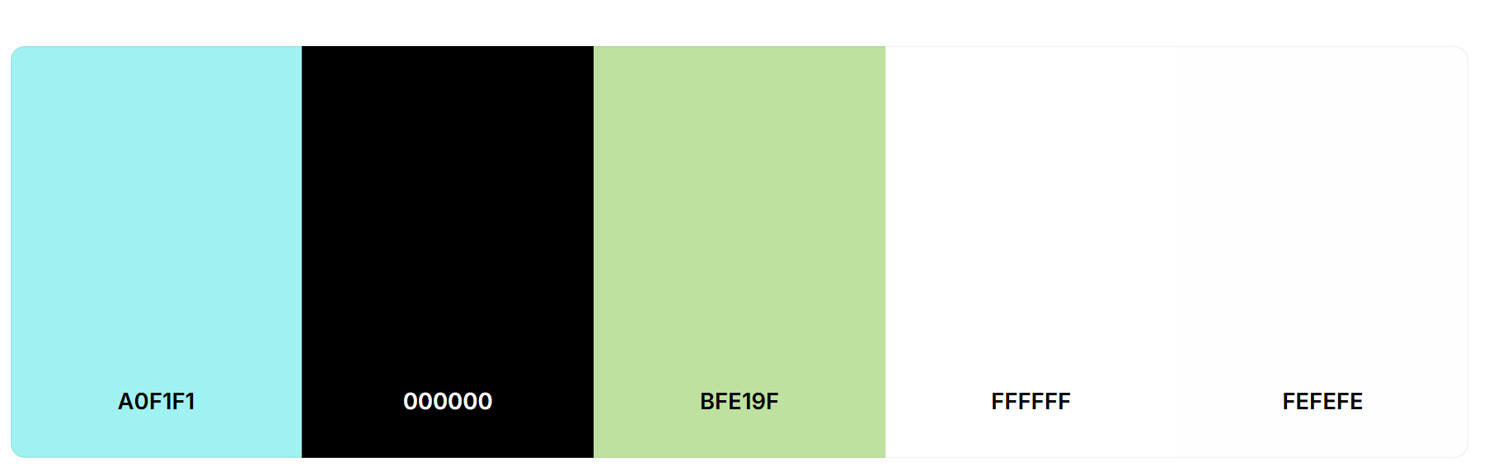
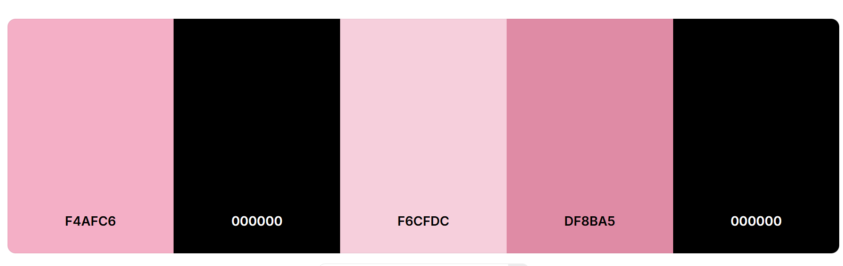

https://coolors.co/palette/fefefe-d91829-9a0c36-f972f5-cc1d53
https://coolors.co/palette/fe0000-e7b0d8-09ffff-f70606-c4aadc
https://coolors.co/palette/a0f1f1-000000-bfe19f-ffffff-fefefe
https://coolors.co/palette/f4afc6-000000-f6cfdc-df8ba5-000000
Asset Sources:
□ Free Resources: Pixabay (sound effects)
□ Original Art: Character animations, all environment art
□ Placeholder Art: Filled basic Unity 2D assets

User Interface (UI) Design
UI Elements Needed:
• Main Menu: Title, Play Button, Quit Button
• HUD (In-Game): Health bar, Score, Timer
• Game Over Screen: Final score, Retry button, Main Menu button
• Victory Screen: Congratulations, Final stats, Play Again
UI Mockup/Layout:
Example HUD Layout:
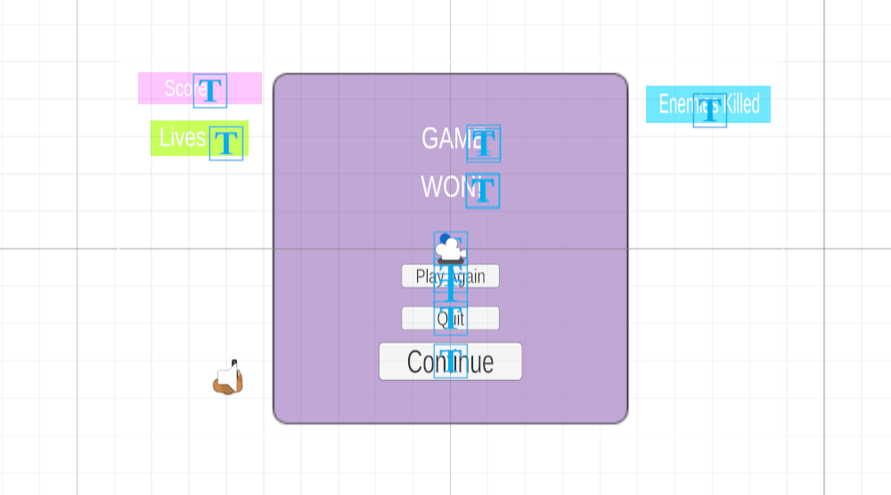
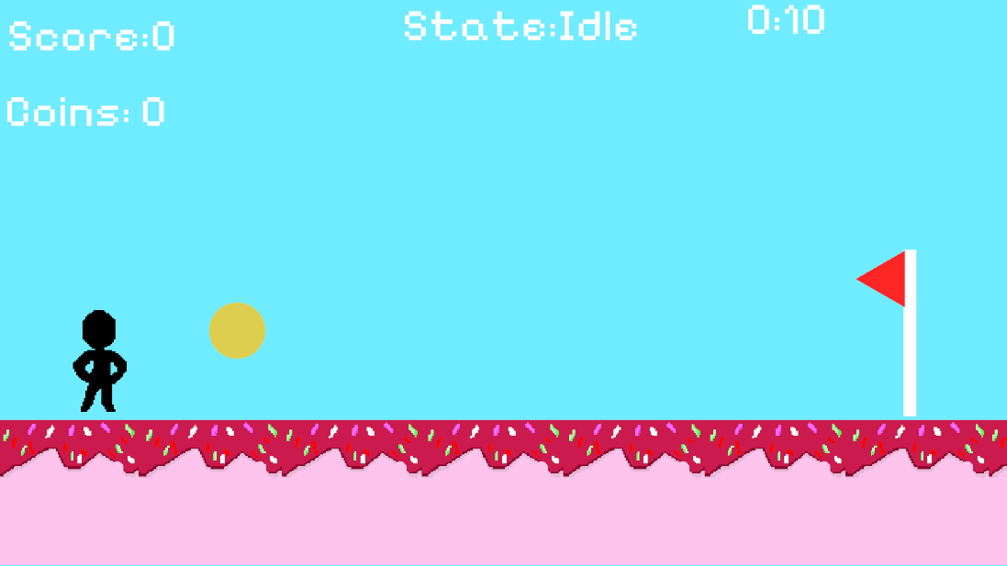

Menu Systems (Map Out)
Menu Flow Diagram:
Main Menu → Credits
Main Menu → Play → Game

Sound Design
Sound Effects:
• Jump, Fire, Enemy Defeat sound effects have been sourced from Pixabay (licenses and links in licenses folder under assets in project GitHub)
Music
• Will be added as possible according to stretch goals

Icon Design

• Description: Pink ice cream cones with sprinkles against a blue background with text that reads “ice cream”
• Colors: 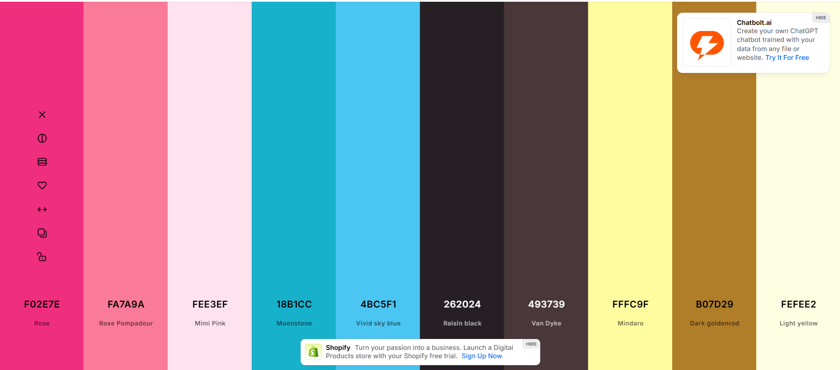
• Rationale: This represents the game because not only are the colors similar to the overall game colors, but it is also vibrant and topical since the game is ice cream/dessert themed

Accessibility Considerations
□ Readable text size (minimum 16pt for UI)
□ Clear audio cues (don't rely solely on visuals)

APPENDIX & RESOURCES

References & Inspiration
• Game 1: Pony Island – platforming levels inspiration
• Game 2: Five Nights at Freddy’s: Pizzeria Simulator – overall pixel art concept and retro feel
• Tutorial/Resource: https://youtu.be/RQd44qSaqww?si=5zNt-rGriyQiojda – What helped to understand state machines
─────────────────────────────────────────────────
Total Page Count: ~5 pages of core content
Word Count Target: 1,200-1,500 words

